# **Relational Model**

# Danielle Park, Gaurav Gulati, Rhett Bramfield

Faculty of Science, University of Calgary

CPSC 471: Database Management System

Prof. Reda Alhajj

February 26, 2025

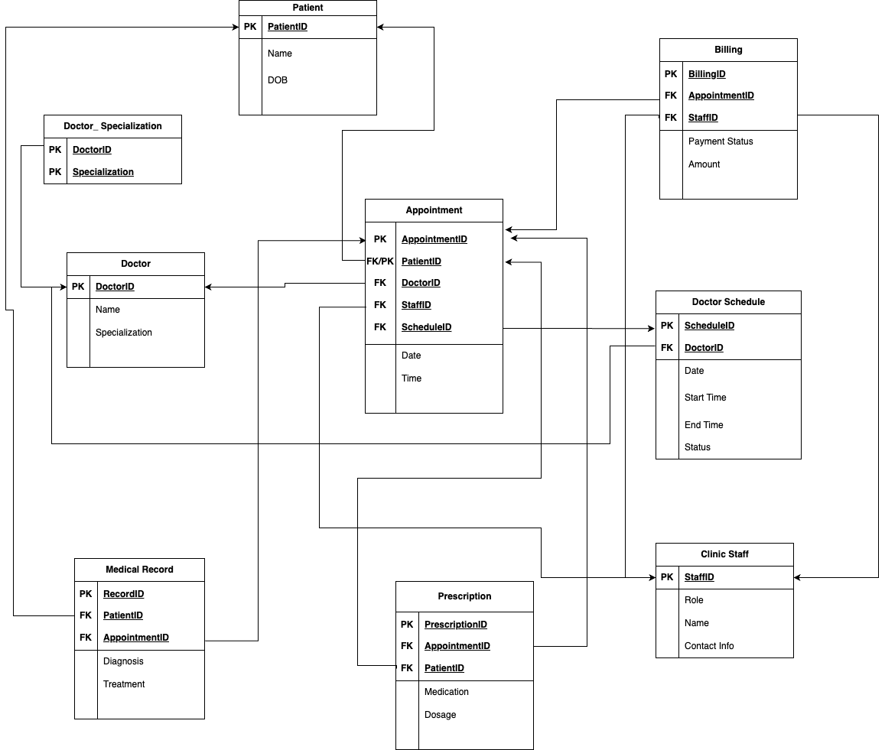

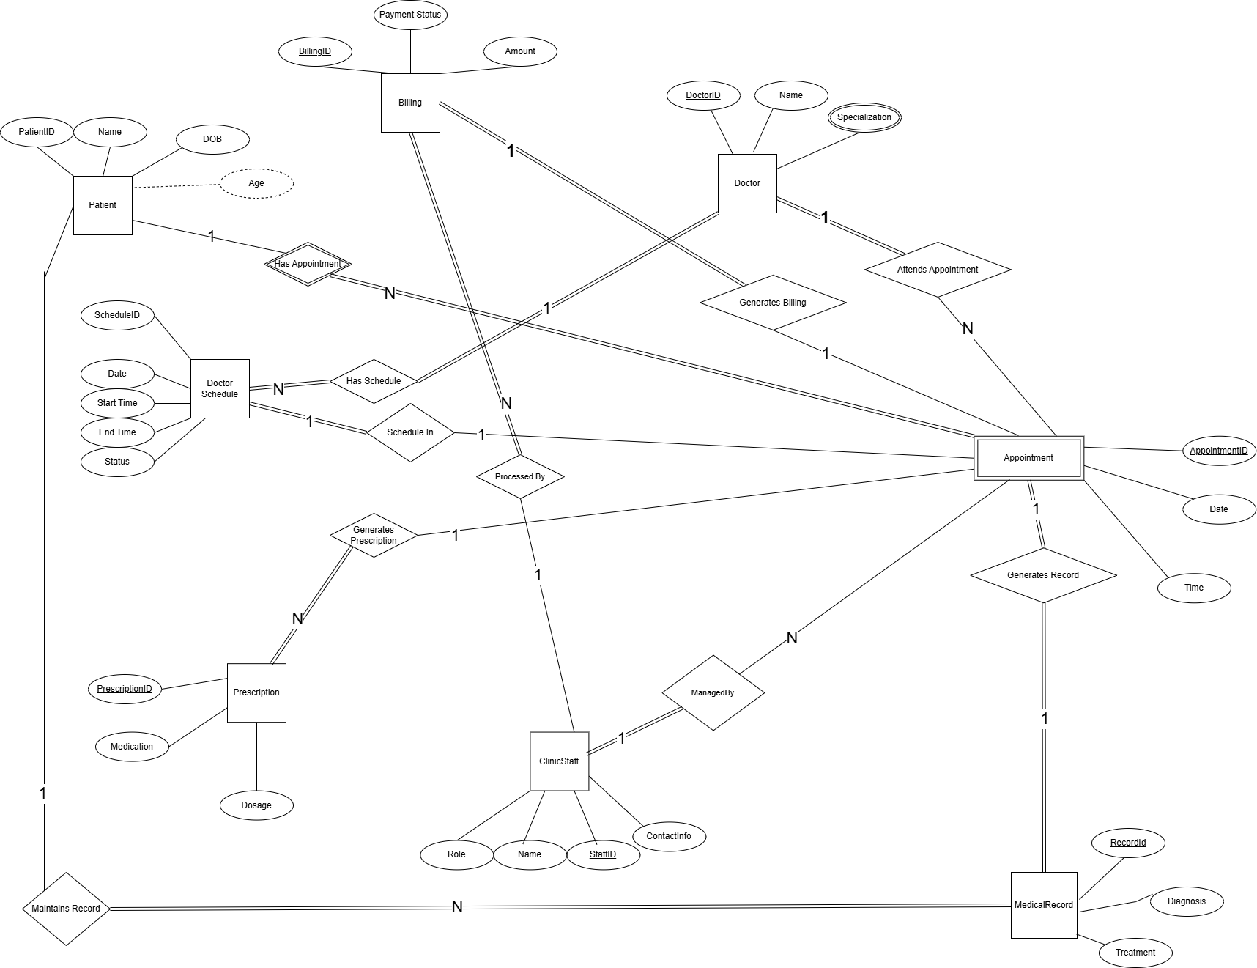Below is the EERD Diagram for our model ( Fixed as per instructions received in the feedback )

## **Summary of Design Assumptions**

(The assumptions are the same as in previous submissions.)

**Weak Entity Designation:**

* + **Appointment** is designated as a weak entity. Although it has an AppointmentID, it is contextually dependent on the Patient who books the appointment (and potentially the DoctorSchedule slot) for complete identification.
* **Integration of Clinical Operations:**
  + The system integrates appointment scheduling, medical record keeping, prescription management, and billing, ensuring a comprehensive approach to clinic management.
* **Clear Role Separation:**
  + Two distinct end-user roles are defined (Patients and Clinic Staff) to ensure appropriate access and operations management within the system.